08/02/23

Guided Exercise: Completing the OpenShift Installation Prerequisites

To complete this guided exercise, install and use the Chromium web browser in the workstation:

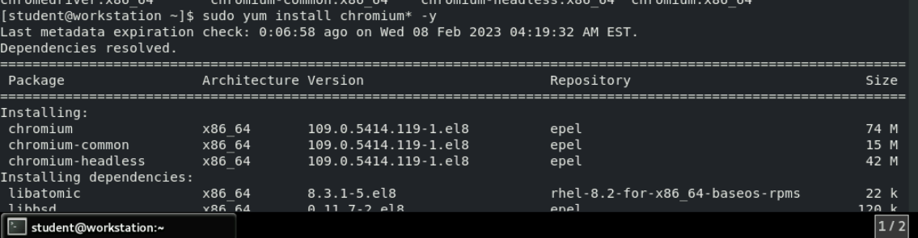

Log in to the utility server as the lab user. Become the root user.

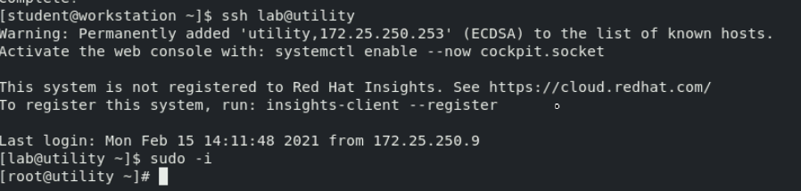

First we need to oc and openshift-install binaries

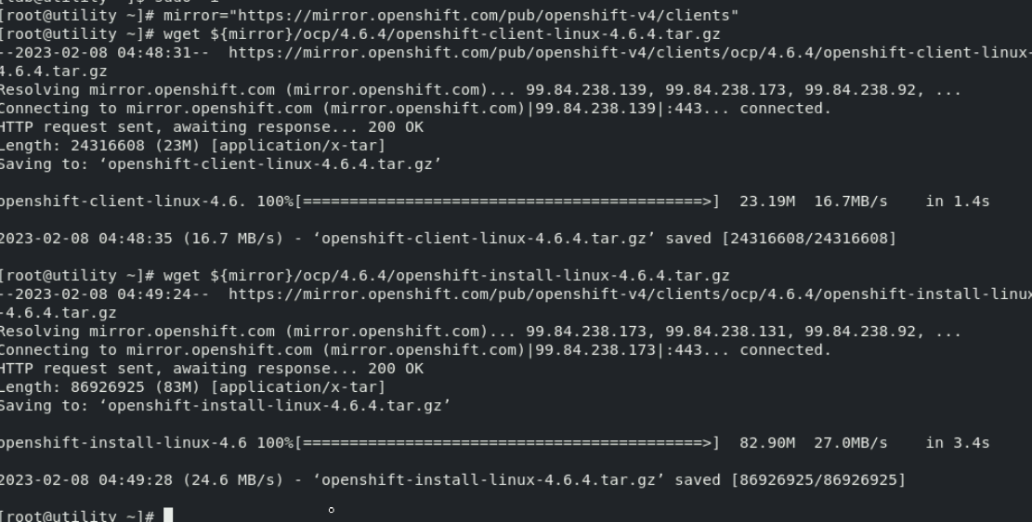

Now extract the download files .After extraction we will get the oc ,kubectl,openshift-install utilitys

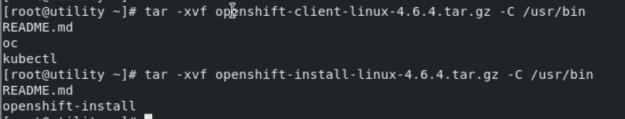

Set the oc and openshift-install bash completion

